PHASE 2 PUBLIC ENGAGEMENT
Email Template
Instructions
Please let this template serve as a guide for when you send out an email to notify your friends/family/neighbors/agency/organization/constituents of the SEAS Update Phase 2 Public Engagement. You may edit and customize as needed.

Subject
Share your input on transportation recommendations for your area!

Email Banner
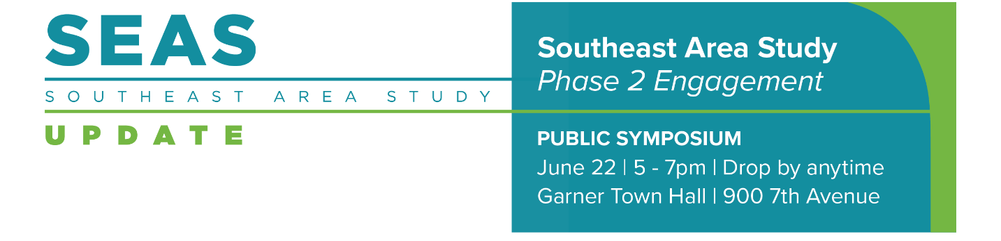
Option to insert image at the top of the email.
Message
Dear _____
Do you care about transportation in your town and area? We want to hear from you!
I’m excited to invite you to get involved in the Southeast Area Study Update. The Capital Area Metropolitan Planning Organization (CAMPO) is updating the 2017 Southeast Area Study (SEAS) to revisit its land use and transportation recommendations. The SEAS Update will serve as a valuable tool to produce project priorities to be included in the next Metropolitan Transportation Plan so it’s critical that community voices are part of this process!
During the last round of engagement, the project team asked about your vision for the Southeast Area in the future. Based on the feedback and the technical analysis, the project team has created a series of draft transportation recommendations. We need your feedback on these recommendations and how to prioritize them!
On Thursday, June 22nd from 5pm to 7pm, the project team will be hosting a drop-in public symposium at Garner Town Hall to collect your feedback on draft roadway, bicycle and pedestrian, and transit recommendations. You’ll also be able to give input on how these projects should be prioritized. If you’re unable to make it to the public symposium, I encourage you to take the online survey to provide your feedback that way. Visit the project website now to get involved: seareastudyupdate.com
This is the second of three rounds of public input, and an opportunity for you to let us know if our transportation recommendations reflect what is important to you. I hope you can take a few minutes to let us know what you think about our transportation recommendations, what projects we should prioritize, and to give feedback and suggestions to further improve transportation in the Southeast Area.
CLOSING, AND SIGNATURE

